**ECE-3502 IoT Domain Analyst LAB(L9+L10)**

**Name: Alpanshu Kataria**

**Reg. No.: 18BCE1267**

**Faculty: Prof. Maheshwari R**

Lab 9

**Task:**

Netflix data manipulation in Knime analytics platform.

**Flow:**

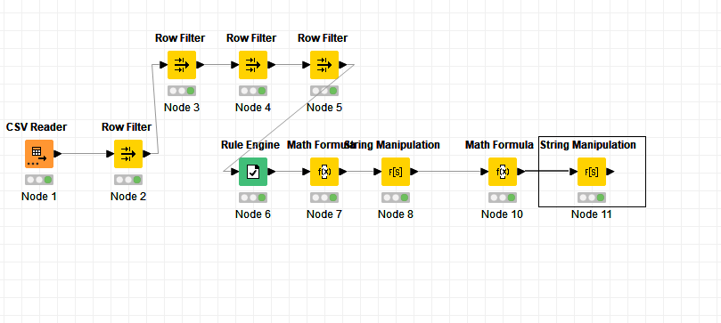**Objective:**

The dataset already consists of a column named duration, that shows duration of movie in minutes and each datapoint is appended with string ‘min’. Using this column I’ll be creating a new column that will show duration of movie in hour and each datapoint will be appended with string ‘hr’. I’ll also try to find out which is the oldest release year for any movie in the dataset.

**CSV Reader:**

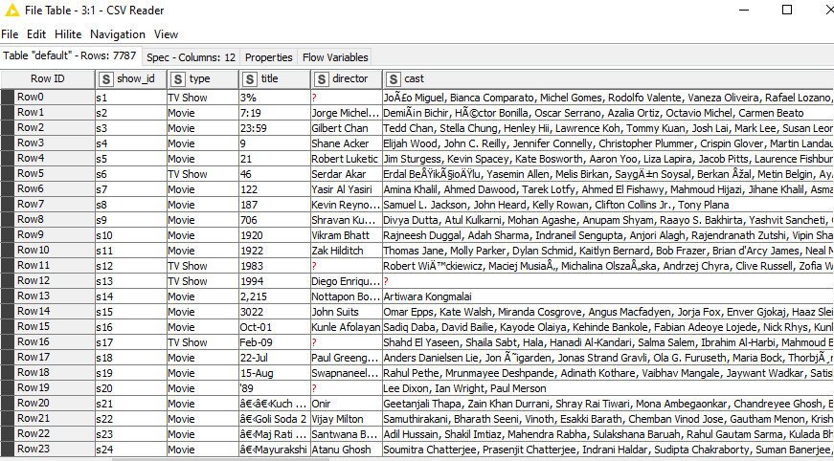

**Then using row filter nodes to remove all empty data points**

**Rule Engine:**

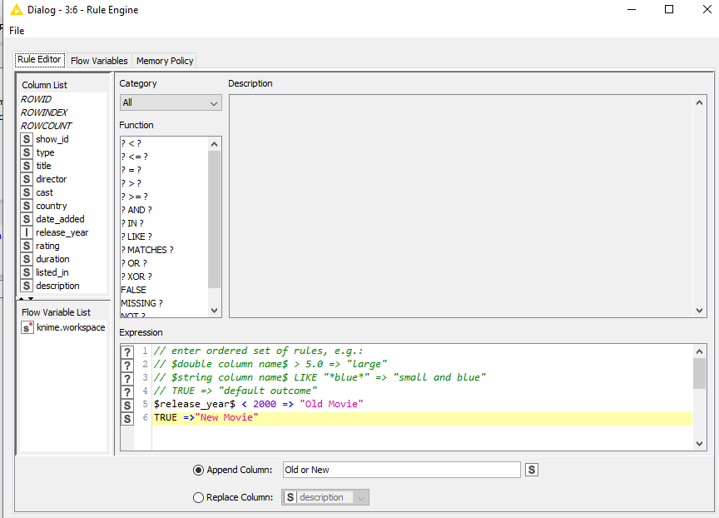

**Math Formula Node:**

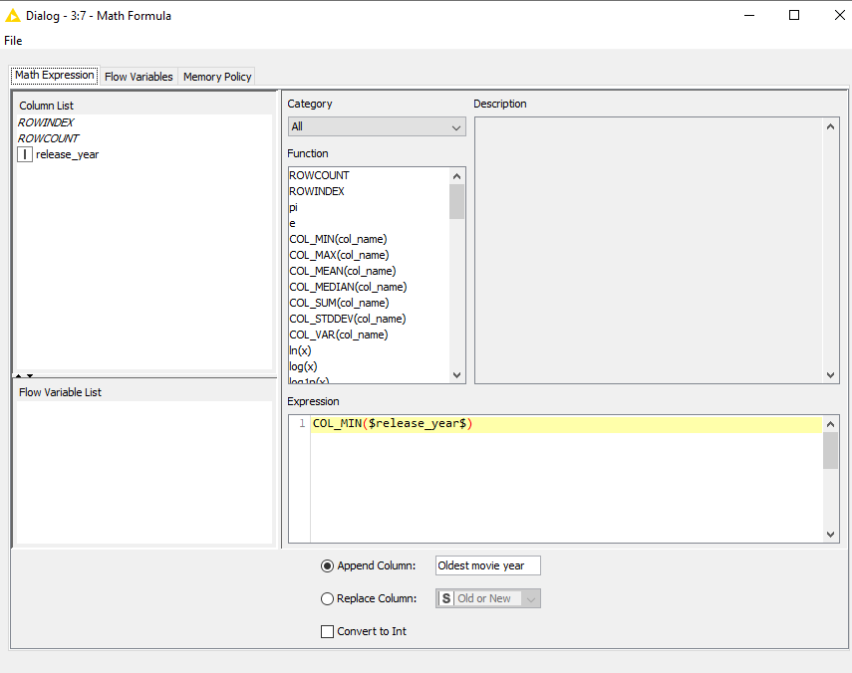

String Manipulation Node 1:

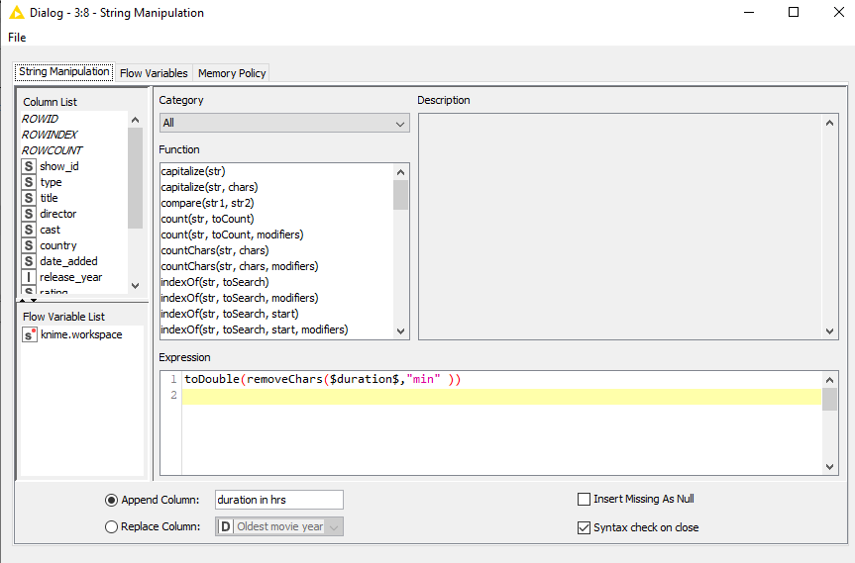

Math Formula 2 Node:

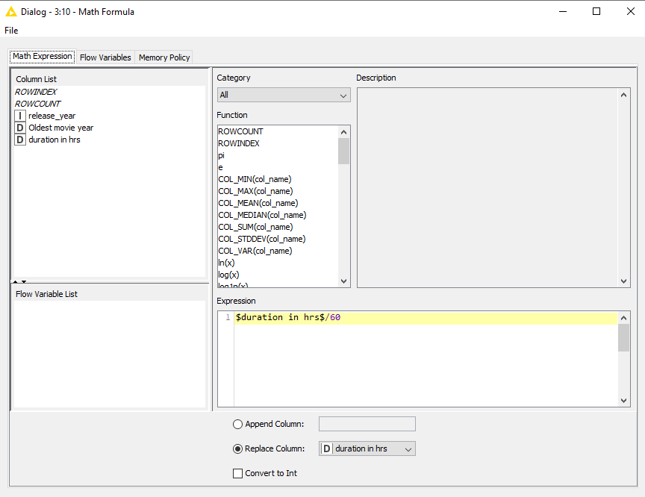

String Manipulation 2:

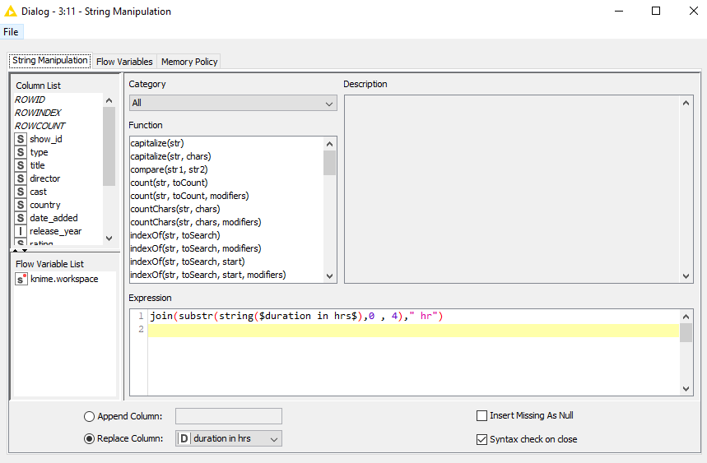

Final Table showing duration of movie in hour:

